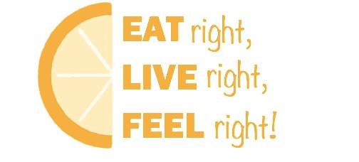
LOYOLA UNIVERSITY CHICAGO • HEALTH SCIENCES DIVISION
Join Us for the Loyola HSD 2019 Nutrition Expo!
Learn about nutrition resources for you and your patients
Presented by the Loyola Dietetic Interns and Stritch School of Medicine Students

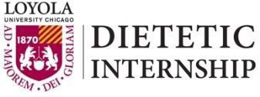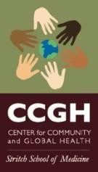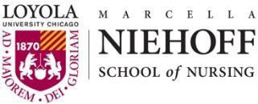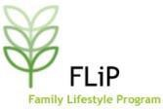Date: Wednesday, April 10, 2019 Location: SSOM Atrium (2nd floor) Time: 10:30am – 2:00pm
National Nutrition Month® 2019

National Nutrition Month® is a nutrition education and information campaign created annually in March by the Academy of Nutrition and Dietetics.
The campaign focuses attention on the importance of making informed food choices and developing sound eating and physical activity habits.
Who: Everyone! Students, Staff, and Faculty
Expo Highlights:
- Cooking demos (and samples!)
- Community resources (CEDA WIC)
- Mediterranean eating pattern
- Dietary Guidelines for Americans
- Medical Nutrition Therapy
- The role of the Registered Dietitian in patient care
- Nutrition support
- Nutrition in public health
- Food access and local community gardens
- The Veggie Rx program

LUHS Nutrition Handbook –
Free to interested individuals; limited availability

For more information, contact:
Joanne Kouba at jkouba@luc.edu

